**Reels rotation (SE3_3)**

Full rotation contains three part : in rotation part, infinite rotation (included but not used), main rotation part, out rotation part.

**Infinite rotation** - event based rotation (used only with async events, like backend …). Not used for in existing scenes. It starts automatically when the reel receives “-1” as NextOrderPosition and continues until the real [0, symbOrder.Length-1] position is received.

The “in”and “out” parts of the rotation are directed opposite to the direction of the main rotation and work as a reverse rotation(only for beaty).

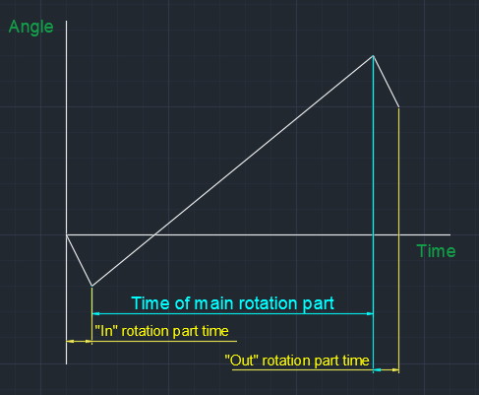

You can adjust settings for each part separately.

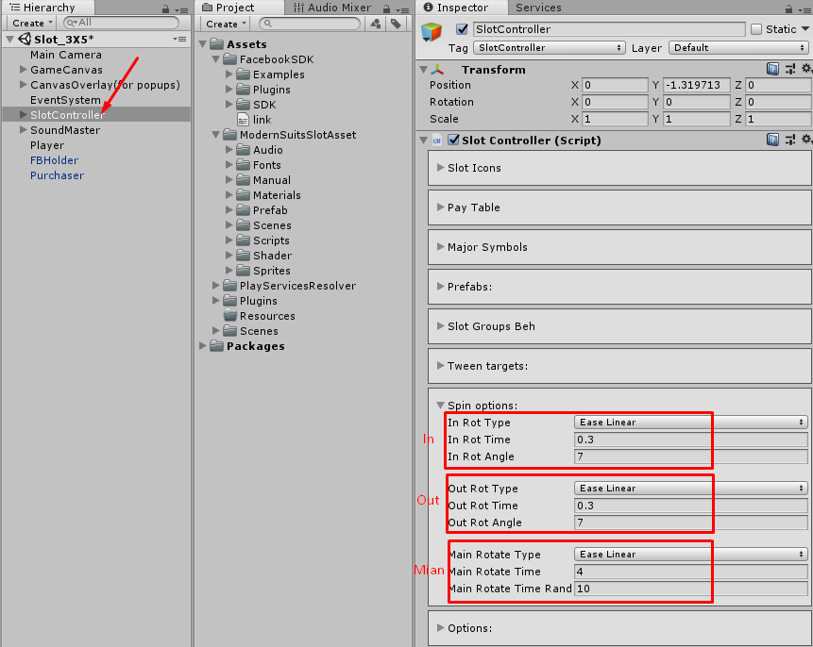

You can set EaseType, rotation part time, and rotation part angle (for the main rotation part, the angle is calculated using a random generator)

You can change the rotation speed for each reel separatelly using multiplier (**Spin Speed Multiplier**), see screen

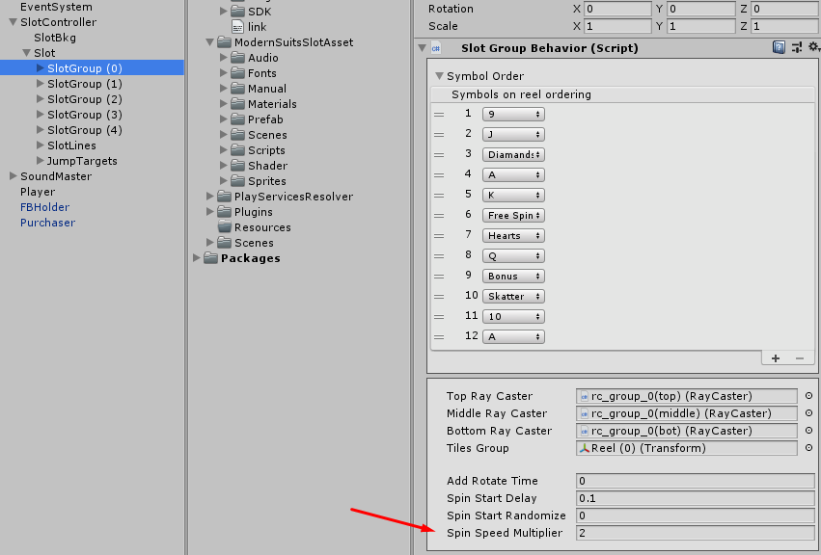

Also you can set for each reel additional rotation time(**Add Rotate Time**), delay time for spin start(**Spin Start Delay**) and randomize spin start delay time (**Spin Start Randomize**)